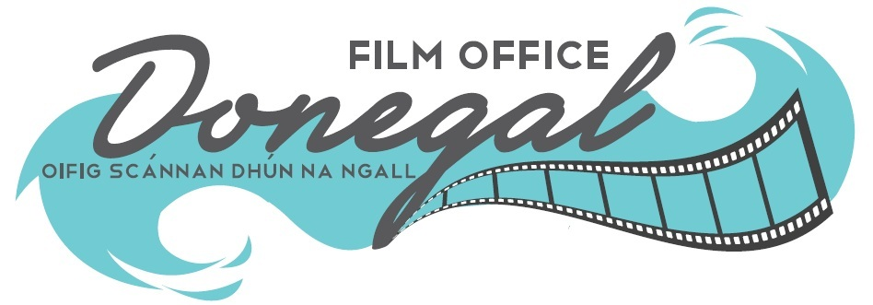

Short Film Bursary Award 2021

This award is funded by Donegal County Council & The National Creative Ireland Programme 2017- 2022 and aims to foster talent, creativity and activity in filmmaking in County Donegal. A grant of €10,000 will be awarded to a filmmaker towards the cost of production of a short drama or documentary film of 10-12 min duration to be shot in Donegal in 2021.

GUIDELINES

We are seeking proposals and applications from film makers who have a script that has been developed, seen by a Director and has had input from a Producer. The Award is in the form of a grant and is set at €10,000 towards the cost of the production.

We are looking for original, entertaining stories by talented filmmakers who, if selected, must set and shoot their project in County Donegal. The Donegal Film Office, based in Donegal County Council, will offer location support and guidance as requested, especially in relation to accessing locations and local resources.

The closing date for receipt of applications is set at 12 noon on Friday 14th May 2021.

Selection Process:

This is a two stage open competition opportunity.

Stage One: Short listing from Applications received.

Stage Two: Interviews are due to take place online throughout May 2021. Any changes to this date will be advised to shortlisted applicants.

What We Require:
- A fully completed Application Form.
- A synopsis of the project (500 words max.) including a general plot outline.
- A copy of the full script (without the writers name).
- A project plan in terms of general shoot requirements.
- Insights with regard to the script from the Director and the Producer.
- A Financial Projection including all costs including the potential bursary award.
- A Revenue Access Number from the Irish Revenue Commissioners.
- Confirmation that you have full legal access to the script you are submitting.

Applications should be emailed to filmoffice@donegalcoco.ie by 12.00 on Friday 14th May 2021. All submissions made on time will be emailed confirmation of receipt.

Bursary Award Guidelines & Conditions:
- High quality propositions are encouraged from filmmakers who have developed a capacity in filmmaking.
2. One of the core creative team (Writer/Director/Producer) must be from or living in Donegal. (Proof of personal address will be required from shortlisted applicants).
3. Applicants must have a short drama script or documentary treatment, of 10-12 minutes in duration with a keen interest to shoot in Donegal. The guiding on film length and duration is 10-12 minutes. Film suggestions longer than 15 minutes are not eligible to apply.
4. Applicants must have full legal rights to the material they are submitting.
5. Applications must show seriousness in terms of intent and ambition for the award. Applications need to include a 500 word synopsis of the project, including a general plot outline, a full script, a project plan in terms of general shoot requirements, as well as insights from a director and a producer. Applications need to display a cognisance of Donegal as a location for filming.
6. A maximum of five applications per person/organisation or legal entity will be accepted. A separate application must be submitted for each application.
7. Opportunities to have the film screened in Donegal will be generated.
8. Donegal County Council as the local statutory body of the State cannot undertake to support a proposition that would be in conflict with its mandate as a local authority.
9. Short Dramas that need significant additional finance, have been part-shot or have been shot entirely are not eligible to apply.
10. The Bursary Grant is to a maximum of €10,000. If a balance of funds is required, then the source must be identified clearly and detailed in your proposal.
11. The shoot must take place in Donegal. Applicants should be in a position to have the production completed including all post production within the calendar year of 2021.
12. If a production has not commenced within three months of Donegal County Council announcing the successful applicant then Donegal County Council retains the right to award the Bursary to number two on the panel.
13. All applicants must have an Irish Revenue Access Number (old Tax Clearance Certificate) from the Office of the Revenue Commissioners in Ireland number and must include this with their application.
14. Codes of Practice Observance; Child First Guidelines including appropriate Garda Vetting procedures, Health & Safety Regulations, Equal Opportunities policies and procedures must be in place and adhered to where relevant and in all cases.
15. Donegal County Council, Donegal Film Office & The National Creative Ireland Programme 2017- 2022 must be acknowledged by the promoter/applicant on all websites and social media platforms, publicity, press and marketing material produced in connection with the Film and Film Bursary Award.
16. Donegal County Council’s log, Donegal Film Office Logo & The National Creative Ireland Programme 2017- 2022 logo must be included in the final cut, in all associated printed material, on posters, flyers etc and on all websites. Copies of all such material produced must be sent to Donegal Film Office offices. Logos can be requested from Donegal Film Office.
17. Please note that Donegal County Council reserves the right not to award the bursary if none of the applications received are deemed to be suitable. In this instance Donegal County Council reserves the right to pursue a different procurement process.
18. Eligibility and compliance with these guidelines and conditions does not guarantee receipt of an award.
19. Acceptance of these conditions and guidelines is implied by submission of an Application to the Film Bursary Award.

Freedom of Information: Donegal County Council proposes that the following information relating to this bursary award application will be made available on request: the name of the successful applicant/s. The reason/s an applicant did not qualify for grant consideration. Donegal County Council undertakes to use its best endeavours to hold confidential, any information provided by applicants subject to its obligations under law, including the Freedom of Information Act 1998 and 2003. Applicants are requested to consider if any of the information supplied should not be disclosed because of its sensitivity. If this is the case, candidates should, when providing the information, identify same and specify the reasons for its sensitivity. If such information is not identified as sensitive and Donegal County Council upon consideration does not deem it sensitive, then such information is liable to be released in response to a Freedom of Information request without further consultation with the applicant. Donegal County Council will consult with any candidates about sensitive information before making a decision on any Freedom of Information Act request received.

